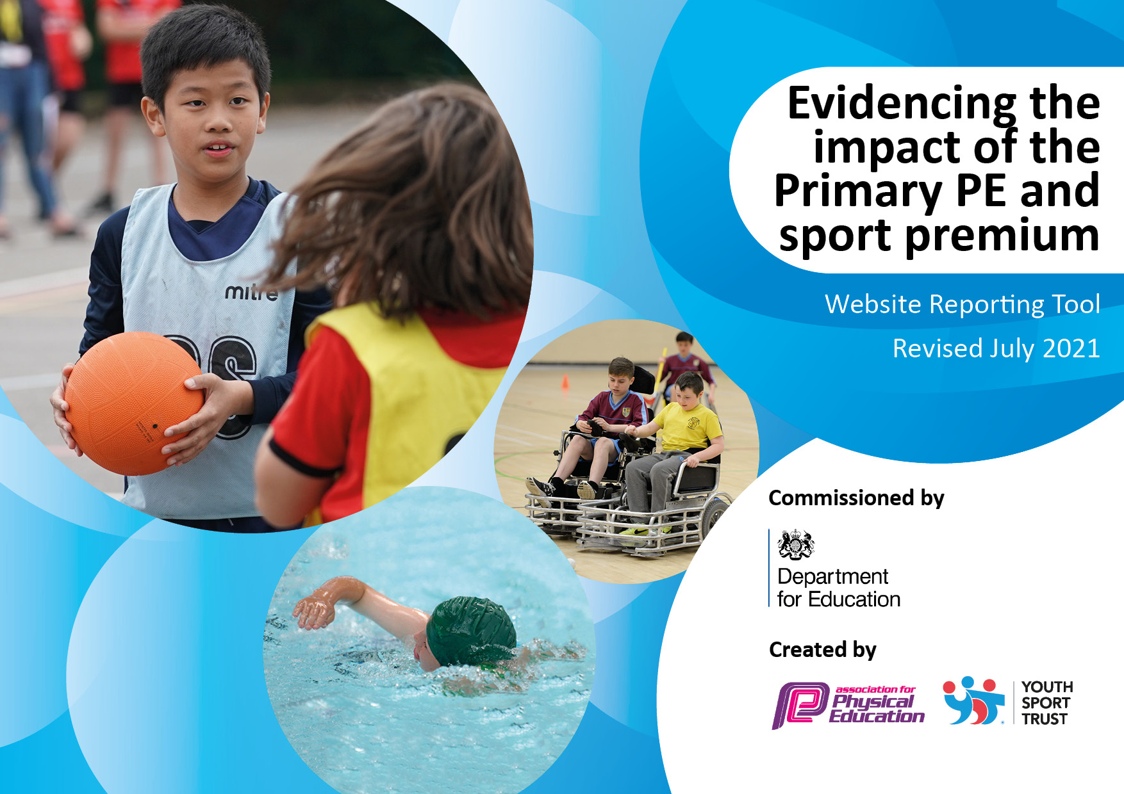
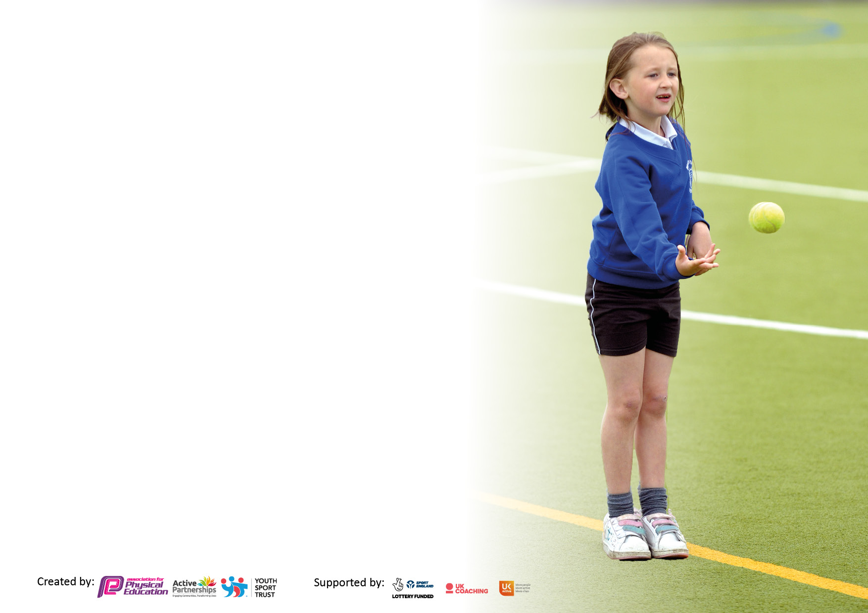

It is important that your grant is used effectively and based on school need. The Education Inspection Framework makes clear there will be a focus on ‘whether leaders and those responsible for governors all understand their respective roles and perform these in a way that enhances the effectiveness of the school’.

Under the Quality of Education Ofsted inspectors consider:
Intent - Curriculum design, coverage and appropriateness
Implementation - Curriculum delivery, Teaching (pedagogy) and Assessment
Impact - Attainment and progress

To assist schools with common transferable language this template has been developed to utilise the same three headings which should make your plans easily transferable between working documents.

Schools must use the funding to make additional and sustainable improvements to the quality of Physical Education, School Sport and Physical Activity (PESSPA) they offer. This means that you should use the Primary PE and sport premium to:

- Develop or add to the PESSPA activities that your school already offer
- Build capacity and capability within the school to ensure that improvements made now will benefit pupils joining the school in future years
- The Primary PE and sport premium should not be used to fund capital spend projects; the school’s budget should fund these.

Pleasevisitgov.ukfortherevisedDfEguidanceincludingthe5keyindicatorsacrosswhichschoolsshoulddemonstrate animprovement.Thisdocumentwillhelpyoutoreviewyourprovisionandtoreportyourspend.DfEencouragesschools to use this template as an effective way of meeting the reporting requirements of the Primary PE and sport premium.

We recommend you start by reflecting on the impact of current provision and reviewing the previous spend.

Schools are required to publish details of how they spend this funding, including any under-spend from 2019/2020, as well as on the impact it has on pupils’ PE and sport participation and attainment. All funding must be spent by 31st July 2022.

We recommend regularly updating the table and publishing it on your website throughout the year. This evidences your ongoing self-evaluation of how you are using the funding to secure maximum, sustainable impact. Final copy must be posted on your website by the end of the academic year and no later than the 31st July 2021. To see an example of how to complete the table please click HERE.
Created by: Supported by:

Details with regard to funding
Please complete the table below.

Total amount carried over from 2019/20 | £0
Total amount allocated for 2020/21 | £19580
How much (if any) do you intend to carry over from this total fund into 2021/22? | £519.80
Total amount allocated for 2021/22 | £19580
Total amount of funding for 2021/22. To be spent and reported on by 31st July 2022. | £20099.8
Swimming Data
Please report on your Swimming Data below.

Meeting national curriculum requirements for swimming and water safety.

N.B. Complete this section to your best ability. For example you might have practised safe self-rescue techniques on dry land which you can then transfer to the pool when school swimming restarts.
Due to exceptional circumstances priority should be given to ensuring that pupils can perform safe self rescue even if they do not fully meet the first two requirements of the NC programme of study
What percentage of your current Year 6 cohort swim competently, confidently and proficiently over a distance of at least 25 metres?  N.B. Even though your pupils may swim in another year please report on their attainment on leaving primary school at the end of the summer term 2021.  Please see note above | 85%
What percentage of your current Year 6 cohort use a range of strokes effectively [for example, front crawl, backstroke and breaststroke]?  Please see note above | 85%
What percentage of your current Year 6 cohort perform safe self-rescue in different water-based situations? | 78%
Schools can choose to use the Primary PE and sport premium to provide additional provision for swimming but this must be for activity over and above the national curriculum requirements. Have you used it in this way? | No

Action Plan and Budget Tracking
Capture your intended annual spend against the 5 key indicators. Clarify the success criteria and evidence of impact that you intend to measure to evaluate for pupils today and for the future.

Academic Year: 2020/21 | Total fund allocated: | Date Updated:
Key indicator 1: The engagement of all pupils in regular physical activity – Chief Medical Officers guidelines recommend that primary school pupils undertake at least 30 minutes of physical activity a day in school |  |  |  | Percentage of total allocation:
 |  |  |  | %
Intent | Implementation |  | Impact
Your school focus should be clear what you want the pupils to know and be able to do and about  what they need to learn and to  consolidate through practice: | Make sure your actions to achieve are linked to your intentions: | Funding allocated: | Evidence of impact: what do pupils now know and what can they now do? What has changed?: | Sustainability and suggested next steps:
To improve children’s range of experience of PE, Sport and Physical Activity to improve:  - Wellbeing  - Enjoyment  - Involvement  - Fitness  - Knowledge of PESSPA  - Inclusion  Continue to provide opportunities for all pupils to compete regardless of ability; E.g. intra-sports competitions (lead and run by SGC, FSC).  Continue to provide a range of lunch time and after school clubs run by Shepway Sports Trust or other Sports coaches  Teaching assistants/Teachers to provide a variety of after school and lunchtime clubs. (Not during terms 3 and 4 due to covid)  Children to run clubs/lunchtime activities to encourage uptake and appreciation of PESSPA.  Find out what activities pupils would like to try.  Replace equipment when needed. | Designated day for PE Coordinator to organise, review and improve school provisions. Also providing lunch time activities and after school.  PE Coordinator has:  promoted and organised participation in. a variety of virtual and face to face competitions through Shepway Sports for the whole school to take part in. Many children received medals for their efforts. Provided virtual training for 16 Year 5 and 6 children to be Sports Crew (organising lunchtime competitions for their peers to take part in) Provided table tennis and swimming after school club.  Successfully re introduced and implemented the daily mile  which saw enthusiastic participation from all students.  Organised CPD for all staff in dance basketball and Hockey as well as a My PB workshop.  Organised by SST  Physical Me - Year 3/4 Multi Sports Festival  Competitive Me - SST Competitive Series - Basketball HEAT 1  Personal Me - KS1 Primary Inclusive Sports Festival  Competitive Me - Yr5/6 SST Football Competition  Personal Me - Yr5/6 Girls Football Festival  Social Me Yr5/6 Netball FSFG 9th June  Yr3/4 Inclusive Sports Event  Yr5/6 Pickleball and Dodgeball at Three Hills  Herald cup football competition  Terms 1-6  Football club x3  Basketball club  Tennis club LTA coach  Table tennis club  Swimming club X2  Yoga Club  Ball skills club  Sports Crew Y5/6 training provided for staff and children (Free). Virtual training planned for Term 2 Supported by PE Coordinator and SG  Pupil survey carried out through Student Council.  Football Goals and footballs  Swimming floats, hats and goggles  Tennis balls  Gym Mats  Hockey equipment  OAA equipment  Javelins  Misc | PE Coordinator (Oncosts £10000)  My PB workshop £247.50  Dance CPD £175  Basketball CPD £175  Hockey CPD and lesson support £130  Events and competitions package 2021/2022 £750.00  Entry fee £40  Per session  Run by TA (£15)  Run by TA (£15)  Free (Charity funded)  Free  Run by TA (£15)  Run by TA (£15)  Free  £522  £180  £60  £497  £195  £258  £156  £280 | A high level of participation in competitions, inclusive sports, a wide variety of clubs and different activities.  Very positive feedback from staff regarding impact of CPD. Teachers are more confident and able to deliver high quality PE lessons.  Staff and pupils becoming more confident using the My Personal best life skills and language in relation to their PE lessons.  There was a high level of participation, engagement and enjoyment from the pupils in a range of competitive, social and inclusive events  Medals won for the pupils in every event.  Children from across the school were given the opportunity to participate and enjoy a wide variety of clubs.  TA’s and Teachers are committed and enthusiastic about delivering high quality sports activities to the children  16 year 5 and 6 children underwent Virtual training to become Sports Crew enabling them to organise lunchtime competitions for their peers to take part in. The children were fully engaged and enthusiastic.  Before we made changes to the curriculum the children were consulted via a survey to find out which sports they would prefer to take part in. Their responses were then taken into consideration.  Ensuring we have the relevant equipment available for the children to use during PE lessons, at after school clubs or at playtimes and lunchtime encourages a high level of enthusiasm and participation. | Continue to organise intra/inter competitions for the whole school.  Choose 8 new members of year 5 for Sports Crew training, to join the existing members.  Continue to promote a wide range of clubs and lunchtime activities with the new sports coach  Continue to promote and encourage whole school participation in the daily mile.  Regular opportunities for staff to take part in relevant CPD  Continue to support staff with the implementation of My Personal Best initiative as a whole school approach to PE lessons.  We will continue to take part in any intra sports competitions that are organised.  To work on building a greater selection of extra-curricular opportunities for children across the school.  Continue to encourage a high level of participation here.  Continue to work with the remaining members of Sports Crew and recruit 8 new members of year 5 for Sports Crew training, to join the existing members.  Continue to involve the children in decision making process and provide frequent opportunities for children to feedback on their PESSPA experiences.  Continue to provide adequate equipment for children to use.  Make sure there is sufficient equipment for the sports to be taught in the re-modelled curriculum.  Regularly monitor condition and levels of equipment in the PE cupboard
Key indicator 2: The profile of PESSPA being raised across the school as a tool for whole school improvement |  |  |  | Percentage of total allocation:
 |  |  |  | %
Intent | Implementation |  | Impact
Your school focus should be clear what you want the pupils to know and be able to do and about  what they need to learn and to  consolidate through practice: | Make sure your actions to achieve are linked to your intentions: | Funding allocated: | Evidence of impact: what do pupils now know and what can they now do? What has changed?: | Sustainability and suggested next steps:
Children, parents and staff to understand the importance of PEPPSA and the benefits physically, emotionally and mentally.  To promote healthy lifestyles.  Inform staff and parents of resources and activities.  Increase participation in Physical Activity outside of PE lessons. Use PA to improve children’s fitness, concentration, coordination and engage in competitive activity.  Celebration of Sports day | Use assemblies to share and promote events and inspire healthy lifestyles.  Use Class dojo to share online resources with parents.  School staff to use Better Health NHS games, resources and recipes to encourage healthy lifestyles.  Use school website sports page and Class Dojo school page to share information with pupils and parents  Display sports calendar and other information on staff notice board.  Purchase and installation of outdoor gym equipment for use at the beginning of the day, at break times and lunch times to involve/engage children in PA outside PE lessons.  Daily mile to be completed daily by all year groups. Daily mile journey around the world with daily mile passports.  Planned for Term 1 2022/23 enjoyment in a variety of sports and  physical activities.  Skip/Box 2Bfit workshops  Tag rugby  Golf  Introduction of Christ Church Mascot | Free  Free  Free  £4034  Skip/Box2Bfit workshop £1175  Mascot costume £269 | Class Dojo was an extremely effective way of sharing sports activities, virtual competitions, lifestyle tips and exercise ideas with parents and children during lockdown. A large number of families took part in a variety of activities and shared photos of them completing them  Our wrap around care afterschool club works hard to promote healthy eating and encourages a variety of activities for the children which include: roller skating, cycling, scootering, table tennis and trampolining.  Pupils and parents were provided with information, ideas and resources to support healthy living choices, even more so during lockdown. Also use to publish events.  The children will have the opportunity to use this equipment upon their return to school in September | Plan a number of Inspiring assemblies for the next academic year. To include an assembly from an International athlete.  Continue the great attitudes promoted at the wraparound care afterschool club.  Continue to inform and engage families using Class Dojo.  Organise a timetable for lunchtime playtime to maximise the opportunities for using this equipment.

Key indicator 3: Increased confidence, knowledge and skills of all staff in teaching PE and sport |  |  |  | Percentage of total allocation:
 |  |  |  | %
Intent | Implementation |  | Impact
Your school focus should be clear | Make sure your actions to | Funding | Evidence of impact: what do | Sustainability and suggested
what you want the pupils to know | achieve are linked to your | allocated: | pupils now know and what | next steps:
and be able to do and about | intentions: |  | can they now do? What has
what they need to learn and to |  |  | changed?:
consolidate through practice:
Encourage teachers to develop their CPD in PE and Sports by taking up the coaching support available with SST or other providers.  Provide teachers with resources and CPD to enable them to teach high quality lessons and clubs confidently and competently.  Keep up to date with PESSPA expectations and share with staff. | It was decided that we would have whole staff CPD sessions ahead of each new term of teaching a different sport. These were arranged for Dance, Basketball and  Hockey as well as a My Personal Best workshop.  Swimming coach training booked for MC for Sept.  PE Hub Membership  AfPE, YST and Gov. Websites  Membership for Table Tennis England  TT kids schools package  Youth Sports Trust membership  Email staff with any updates and invite feedback. | My PB workshop £247.50  Dance CPD £175  Basketball CPD £175  Hockey CPD and lesson support £130  Swimming course £375  £350  Free  Free  Free  £210 | CPD from experienced sports staff has meant teachers now feel more confident to teach lessons and run clubs.  PE Hub provides easy to follow resources with videos to support teaching of PE.  YST provided a variety of useful resources and CPD to support teaching and providing PA during play and lunch times.  Staff are well informed and know where to come for help and advice. If the PE coordinator cannot assist then she ensures to find a way of finding answers. | Review and repeat survey annually.  We plan to run several whole school CPD sessions ahead of the term we will be teaching specific sports.  Continue to subscribe to PE hub as a planning tool. Continue incorporating the MY PB initiative.  Continue to follow My PB initiative which fits really well with our school vision. My PB training for Charlie-the new sports coach.  PE coordinator to keep up to date with PESSPA expectations pursue any professional development opportunities and share with staff.
Key indicator 4: Broader experience of a range of sports and activities offered to all pupils |  |  |  | Percentage of total allocation:
Intent | Implementation |  | Impact
Your school focus should be clear | Make sure your actions to | Funding | Evidence of impact: what do | Sustainability and suggested
what you want the pupils to know | achieve are linked to your | allocated: | pupils now know and what | next steps:
and be able to do and about | intentions: |  | can they now do? What has
what they need to learn and to |  |  | changed?:
consolidate through practice:
Work with local agencies to provide a wider range of activities that will inspire our children to take up sports. Choose activities that have low running costs.  Find out what PESSPA the pupils would like to do. | Terms 1-6  Football club x3  Basketball club  Tennis club LTA coach  Table tennis club  Swimming club X2  Yoga Club  Ball skills club  Pupil Survey/student council | Per session  Run by TA (£15)  Run by TA (£15)  Free (Charity funded)  Free  Run by TA (£15)  Run by TA (£15) | Children from all year groups were given the opportunity to enjoy and experience a wide range of sports and activities.  Children felt empowered when asked for their opinions. | Work on building up the number and variety of clubs offered next academic year both in school and out. Ensure that every child has the opportunity to take part in an activity.  Repeat surveys regularly

Key indicator 5: Increased participation in competitive sport |  |  |  | Percentage of total allocation:
 |  |  |  | %
Intent | Implementation |  | Impact
Your school focus should be clear | Make sure your actions to | Funding | Evidence of impact: what do | Sustainability and suggested
what you want the pupils to know | achieve are linked to your | allocated: | pupils now know and what | next steps:
and be able to do and about | intentions: |  | can they now do? What has
what they need to learn and to |  |  | changed?:
consolidate through practice:
Continue to provide opportunities for all pupils to compete regardless of ability; E.g. intra-sports competitions (lead and run by SGC, FSC).  To book A, B and C team onto Shepway Sports Trust events, so all children have the opportunity to participate in sport events.  Provide Transport | Organised by SST  Physical Me - Year 3/4 Multi Sports Festival  Competitive Me - SST Competitive Series - Basketball HEAT 1  Personal Me - KS1 Primary Inclusive Sports Festival  Competitive Me - Yr5/6 SST Football Competition  Personal Me - Yr5/6 Girls Football Festival  Social Me Yr5/6 Netball FSFG 9th June  Yr3/4 Inclusive Sports Event  Yr5/6 Pickleball and Dodgeball at Three Hills  Herald cup football competition  Book Cross Keys, R&J Coaches or  Folkestone sports centre Mini bus for transport to sports events. | Events and competitions package SST 2021/2022 £750.00  £40  £0 | There was a high level of participation, engagement and enjoyment from the pupils in a range of competitive, social and inclusive events  Medals won for the pupils in every event. | Ensure that the school is well represented at face to face events and all children are given the opportunity to take part.  Transport to be booked in advance for any sports events outside of school.

Signed off by
Head Teacher: | Robin Flack
Date: | 31/07/22
Subject Leader: | Esther Denham
Date: | 31/07/22
Governor: | Ron Chitty
Date: | 31/07/22

