
Special Educational Needs and Disabilities (SEND) Information Report

Striving to be best version of ourselves, everyday
God said, “You are precious in my eyes and I love you.” (Issiah 43:4)
Inspired by God’s love, we humbly strive to be
the best version of ourselves every day, in every way.

We cherish the dignity of each precious person:
thankfulness, friendship, forgiveness and hope
are at the heart of our inclusive community.

Inclusion Team
SEND Governor:
Mrs Sue Dinsdale
SENCO
Mrs Maeve Renard (Assistant Headteacher)
Contact: m.renard@christ-church-folkestone.kent.sch.uk
Mrs Claire Reigate (Deputy SENCO)
Miss Rebecca Perkins (Deputy Headteacher & DSL)
Mrs Jo Diwell (FLO)
Mrs Carter (Reading Lead & Chaplain)

Approved by: | The Full Governing Body | Date: 18th June 2025
Last reviewed on:
10/09/2026
Next review due by: | Annually

Contents
1. What types of SEND does the school provide for? 4
2. Which staff will support my child? 5
3. What should I do if I think my child has SEND? 7
4. What happens if the school identifies a need? 8
5. How will the school measure my child’s progress? 9
6. How will I be involved in decisions made about my child’s education? 10
7. How will my child be involved in decisions made about their education? 11
8. How will the school adapt its teaching for my child? 12
9. How will the school evaluate whether the support in place is helping my child? 13
10. How will the school ensure my child has appropriate resources? 13
11. How will the school make sure my child is included in activities alongside pupils who don’t have SEND? 14
12. How does the school make sure the admissions process is fair for pupils with SEN or a disability? 15
13. How does the school support pupils with disabilities? 15
14. How will the school support my child’s mental health and emotional and social development? 16
15. What support is in place for looked-after and previously looked-after children with SEN? 16
16. What support will be available for my child as they transition between classes or settings or in preparing for adulthood? 17
17. What support is available for me and my family? (Local Offer) 18
18. What should I do if I have a complaint about my child’s SEND support? 19
19. Supporting Documents…………………………………………………………………………………………………………….19
20. Glossary 20

Dear parents and carers,
The aim of this Information Report is to explain how we implement our SEND policy. In other words, we want to show you how SEND support works in our school. Our ethos follows in the example of Jesus whose commitment was to the dignity and ultimate worth of each person, rooted in each being created in the image of God and loved by God.
As a Christian school, our vision of ‘Striving to be the best version of ourselves, everyday’, underpins all that we do. We uphold a vision for education centered on dignity and respect, which we believe enables all children to flourish, learn and grow alongside others in our world of increasing diversity. We believe that all children should feel, loved, guided, held and never alone. Flourishing children enjoy education; they learn and grow in a wide variety of well-designed curriculum experiences, across a broad range of subject disciplines, not simply those that are publicly assessed. We recognize that children flourish at different times and speeds. All children deserve to love their childhood, finding space for play, exploration, imagination and creativity, surrounded by loving relationships, structures and systems which enable them to enjoy a ‘life in all its fullness’ (John 10:10). Flourishing children learn that no-one really flourishes unless we flourish together – Ubuntu. Where collaboration, support and celebration of the other is prioritised over competition and comparison.
As educational professionals, we are all working towards the ultimate goal of growing independent young people as they prepare for adulthood. Supporting children onto adult life through an educational journey that fills them with courage, compassion and commitment. All provision and support we provide is working towards achieving the Kent Children and Young People (CYP) Outcomes Framework:
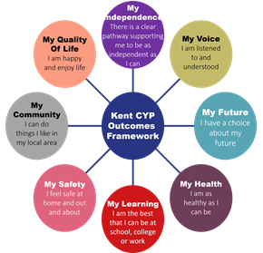

If you want to know more about our arrangements for SEND, read our SEND policy alongside this Information Report.
You can find our SEND policy on our website https://www.christchurchfolkestone.com/learning/special-educational-needs/
Note: If there are any terms we’ve used in this information report that you’re unsure of, you can look them up in the Glossary at the end of the report.

1. What types of SEND does the school provide for?
Our school provides for pupils with the following needs (as outlined in the SEND Code of Practice 2015):

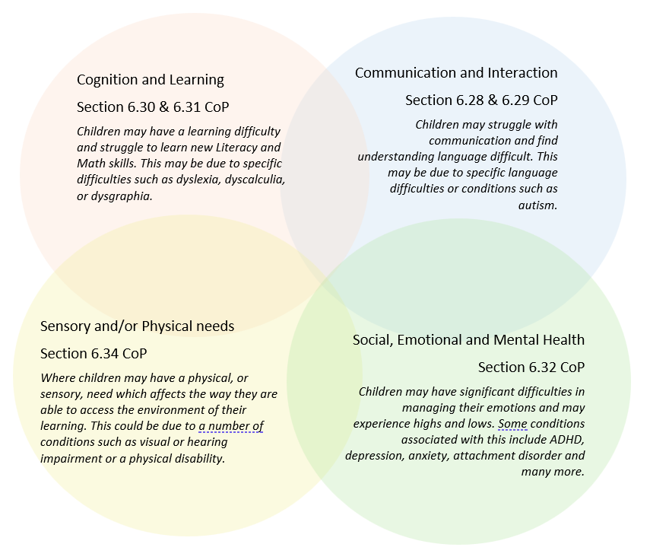
Often you will find that children’s needs overlap and are rarely confined to one area of need, which is why it is important to gain a wholistic overview of your child. More information about the Areas of Need can be found in the Special educational needs and disability code of practice: 0 to 25 years (link below).
SEND_Code_of_Practice_January_2015.pdf (publishing.service.gov.uk)

2. Which staff will support my child, and what are their key responsibilities?
At Christ Church CEP Academy all staff are considered responsible for supporting the needs of pupils with SEND. Our staff are committed to regular, high-quality training to ensure that they have the knowledge and skills to better meet a wide range of pupil needs.
Below outlines key staff who will be supporting your child. Please note that this list is not exhaustive.
Mis Perkins  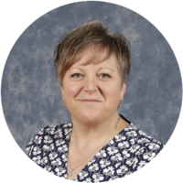  Deputy Headteacher (DSL) | Mrs Renard    Assistant-Headteacher/SENCO
Mrs Reigate  Deputy SENCO | Mrs Carter    Reading Lead & Chaplain
Mrs Reene    HLTA – Reading recovery | Mrs Diwell    Family Liaison Officer
Class/subject teachers
All of our teachers receive in-house SEN training and when appropriate training from outside agencies, and are supported by the SENCO to meet the needs of pupils who have SEN. Training is ongoing.
Examples of training our staff have received are:
Makaton training,
Autism Awareness
Proact Skip training
Sensory circuits
Active communication

Teaching assistants (TAs)
We have a team of TAs, who are trained to support SEN provision.
We also have a number of teaching assistants spread across the school who are trained to deliver interventions such as
- speech and language
- Fizzy/clever hands
- Better Reading Partnership
- Sensory circuits
TA’s receive regular training, some examples of training received are:
Read Write Inc training (Early phonics)
Manipulatives to support maths,
ProAct skip training,
Better Reading Partnerships,
Speech and language
Active communication.

External agencies
Sometimes we need extra help to offer our pupils the support that they need. Whenever necessary we will work with external support services to meet the needs of our pupils with SEND and to support their families. These may include:

- Child and adolescent mental health services (CAMHS)

- Church Street counselling services
- Education welfare officers
- Educational psychologists
- Early Help
- GPs or paediatricians
- Home start
- NELFT practitioners
- Occupational therapists
- Porchlight project
- Therapeutic practitioners
- Behaviour coaches
- Safeguarding services
- School Liaison Officer
- School nurses
- SEND Inclusion Advisor
- Specialist Teacher Service
- Speech and language therapists



- Voluntary sector organisation

3. What should I do if I think my child has SEND?

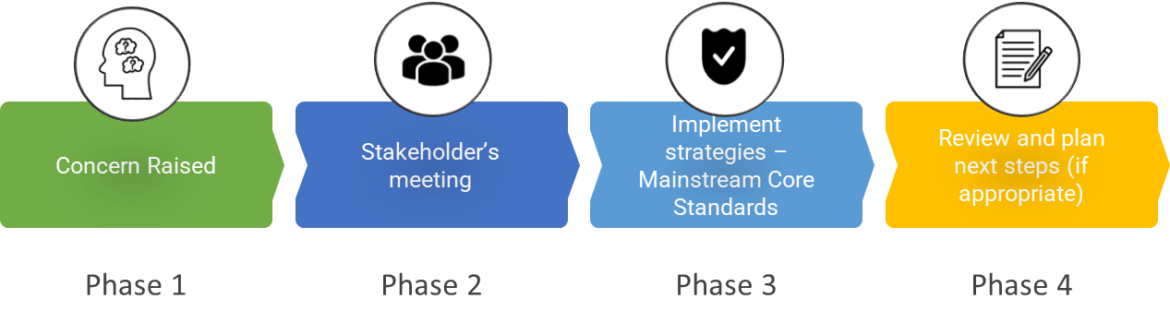

Phase 1 | If you think your child might have SEND, raise your concern with the school so that the SENCO is aware. Contact your child’s teacher or SENCO on dojo, this is the easiest and quickest way,  
Phase 2 | We will meet with you to discuss your concerns and try to get a better understanding of what your child’s strengths and difficulties are. Together we will decide what outcomes to seek for your child and agree on next steps. We will create a record of meeting and add this to your child’s record.  This meeting may be with the FLO, your child’s teacher or with the Senco
Phase 3 | We will implement the agreed strategies and monitor these over an agreed period of time. These are likely to be universal strategies set out in the mainstream core standards. A copy of this can be found here: https://www.kelsi.org.uk/__data/assets/pdf_file/0005/117257/Special-educational-needs-mainstream-core-standards-guide-for-parents.pdf . This will initiate the ‘Graduated Approach’ where support will be continually reviewed. See next page for more details.
Phase 4 | If we decide that your child needs SEND support, we will formally notify you and your child will be added to the school’s SEND register. They will receive additional support and this will be reviewed using the assess, plan, do, review model.

4. What happens if the school identifies a need?
The same process is followed if a concern is raised by the school.

All our class teachers are responsible for the monitoring of all pupils who have been identified as having SEND. They also review those who are not making the expected level of progress in their schoolwork, socially or emotionally. This might include academic attainment, or though monitoring social interactions and emotional well-being.
If the teacher notices that a pupil is having difficulties, they try to find out if the pupil has any gaps in their learning. If they can find a gap, the school will provide appropriate support. Pupils who don’t have SEND usually make progress quickly once the gap in their learning has been filled.
If the pupil is still finding it difficult to make the expected progress, the teacher will talk to the SENCO, and will contact you to discuss the possibility that your child has SEND, the school will follow the graduated approach.

5. How will the school measure my child’s progress?

A range of assessments are used to establish an individual pupils’ needs. The academic progress of SEND pupils at Christ Church is monitored in the same way as all pupils across the school, using our school assessment system. All children are assessed in Maths, Reading and Spelling, Punctuation and Grammar (SPAG) at least three times a year. These curriculum assessments show if a child is working towards, working at or working above age expectations.
At Christ Church, we promote children as unique individuals. This is evident with every child’s learning style, and for some children we recognise this can be in smaller steps, therefore we believe that this should be celebrated for all learners.
If your child is working below the below the standard of national curriculum assessments, we will assess your child, using the small steps approach recommended by Kent.
Your child’s progress will be assessed both in terms of his/her regular learning within the class and with regard to specific intervention programmes.
We will follow the ‘graduated approach’ to meeting your child’s SEND needs.
The graduated approach is a 4-part cycle of assess, plan, do, review.
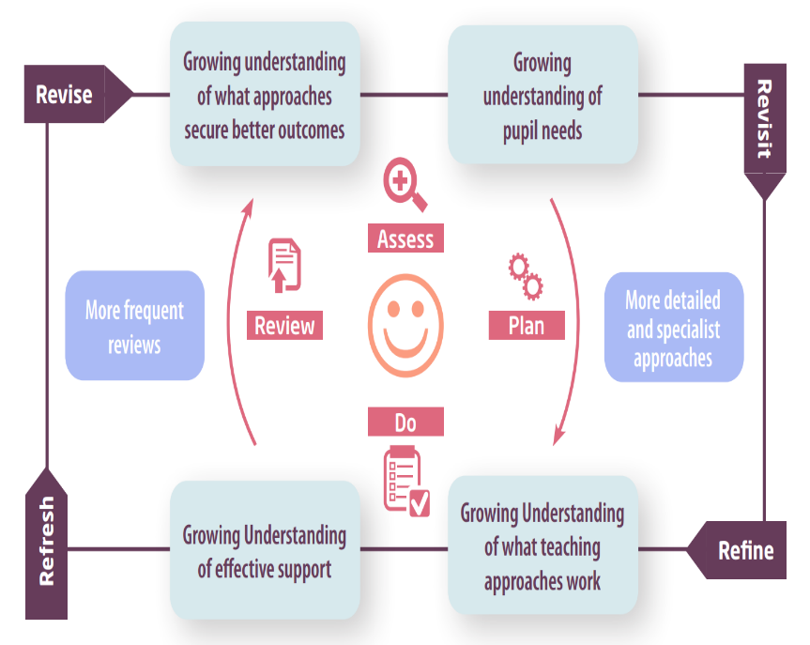

Assess | If your child is not making the expected level of progress, we will make an assessment to find out what strengths and difficulties your child has. We will ask for you and your child’s input, as well as getting help from external professionals where necessary.
Plan | In discussion with you and your child, we will decide what outcomes we are hoping to achieve. We will make a plan of the support we will offer your child to help them meet those outcomes. We will make a record of this and share it with you and all relevant school staff.
Do | We will put our plan into practice.  The class teacher, with the support of the SENCO, will be responsible for working with your child on a daily basis, and making sure the support we put in place is having the impact we intended.
Review | We will assess how well the support we put in place helped the pupil to meet the outcomes we set. We will use our improved understanding of your child’s needs to improve the support we offer; this may mean the Plan, Assess, Do, Review cycle continues.

6. How will I be involved in decisions made about my child’s education?
We will provide an annual written report on your child's progress in July.
There will be two opportunities within each academic year to meet the teacher during parents- evenings,( November and March).
There will also be three reviews throughout the year with the Senco to ensure the implementation of ‘The Graduated Approach’, for those children on SEN Support and EHCP plans. During these reviews we will use the assess, plan, do, approach.
- Set clear outcomes for your child’s progress
- Review progress towards those outcomes
- Discuss the support we will put in place to help your child make that progress
- Identify what we will do, what we will ask you to do, and what we will ask your child to do
We know that you’re the expert when it comes to your child’s needs and aspirations. So, we want to make sure you have a full understanding of how we’re trying to meet your child’s needs, so that you can provide insight into what you think would work best for your child.
We also want to hear from you as much as possible so that we can build a better picture of how the SEND support we are providing is impacting your child outside of school.
If your child’s needs or aspirations change at any time, please let us know right away so we can keep our provision as relevant as possible.
If you have concerns that arise between these meetings, please contact your child’s teacher or Senco via Class Dojo.

7. How will my child be involved in decisions made about their education?

The level of involvement will depend on your child’s age and individual needs. We recognise that no two pupils are the same, so we will decide on a case-by-case basis, with your input.
We may seek your child’s views by asking them to:
- Attend meetings to discuss their progress and outcomes
- Complete an emotional well-being survey.
- Discuss their views with a member of staff who can act as a representative during the meeting
- Share their hopes and dreams of for their future



8. How will the school adapt its teaching for my child?
We believe in order for all children to flourish, all children are entitled to universal high-quality teaching, adapted to children’s individual needs to enable them to access the curriculum. Your child’s teacher is responsible and accountable for the progress and development of all the pupils in their class.
Lessons will be adaptive to support children in accessing the curriculum at a level appropriate to their learning and developmental stage. The lessons take into account children’s needs and they are planned in order to remove any barriers to the curriculum. Using High Quality Teaching strategies from the beginning is the best way to support all learners and reduce the number of pupils who need extra support. There is no 'one size fits all’ approach to adapting the curriculum, we work on a case-by case basis to make sure the adaptations we make are meaningful to your child and are guided by the Mainstream Core Standards in the first instance.
All children who are on the SEND register will have additional targeted support and provision. This may consist of adult support, interventions, resources, environmental adaptations, additional assessments and the involvement of external professionals where needed
It is our intention to remove, as far as we can, those barriers which make it hard for children and adults with a disability to take part in the day to day life of our school and benefit from the educational experiences and services we provide. We aim to ensure that our school is a welcoming place that understands and responds effectively to children and adults with disabilities and we recognise the importance of a review and planning procedure associated with continuous development and improvement. You may wish to click on our accessibility plan here for more information: accessibility plan.
These adaptations may include:
- Adapting our approaches, for example, giving longer processing times, pre-teaching and overlearning of key vocabulary, brain breaks, use of indoor/outdoor learning environments, flexible groupings etc.

- Adapting our resources and staffing

- Using recommended aids, such as ear defenders, wobble cushions, coloured overlays, visual timetables, larger font, etc.

- Access to our nurture provision through our Flourishing Curriculum

- Teaching assistants or support staff will support pupils appropriately depending on their presentation of need

- Explicit instruction, modelling and scaffolding lesson materials

We may also provide the following interventions/therapies:
Speech & language, reading, inference, maths, art therapy, outdoor explorer, play therapy, lunch time clubs This is not an exhaustive list and it is flexible depending on the needs of the children.
These interventions are part of our contribution to Kent County Council’s local offer.

9. How will the school evaluate whether the support in place is helping my child?

We will evaluate the effectiveness of provision for your child by using the assess, plan, do approach.
- Reviewing their progress towards their goals every second term
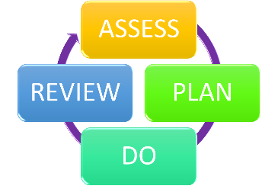
- Reviewing the impact of interventions after 6 weeks
- Using pupil questionnaires
- Monitoring by the SENCO
- Using provision maps to measure progress
- Holding an annual review (if they have an education, health and care (EHC) plan)

10. How will the school ensure my child has appropriate resources?

It may be that your child’s needs mean we need to provide additional resources such as:
- Additional resources to support their learning
- Adaptations to in class support
- Further training for our staff
- External specialist expertise
Where appropriate, we will consult with external agencies to get recommendations on what will best help your child access their learning and use our best endeavours to ensure these are supplied.

11. How will the school make sure my child is included in activities alongside pupils who don’t have SEND?


Following our Christian Ethos, we believe that all children should be able to access their classroom and build friendships with their peers. Celebrating the journey that each individual child is on. We want all children to receive a broad and balanced education, which is suitable for their needs. It may be necessary for some pupils at different times within a school year to receive interventions to support their needs in addition to a broad and balanced curriculum.
All of our extra-curricular activities and school visits are available to all our pupils, including our before and after-school clubs.
All pupils are encouraged to go on our school trips, including our residential trip in year 6.
All pupils are encouraged to take part in; sports day, school plays, special workshops and whole school curriculum days such as spiritually, PE, music and worldviews.
No pupil is ever excluded from taking part in these activities because of their SEN or disability and we will make whatever reasonable adjustments are needed to make sure that they can be included.

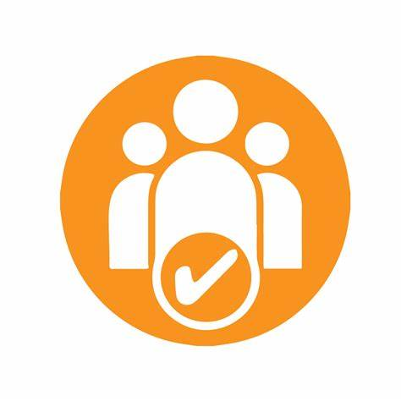
12. How does the school make sure the admissions process is fair for pupils with SEN or a disability?

We are an inclusive Academy, welcoming children from all backgrounds and abilities. It is our wish to allow parents the right to have a place at the school of their choice. The only restriction on entry is number, where there is an excess demand on Academy places available.
ADMISSIONS AND OVERSUBSCRIPTION CRITERIA
Before the application of oversubscription criteria, children with an Education, Health and Care Plan, which names the Academy, will be admitted. As a result of this, the published admissions number will be reduced accordingly.
The oversubscription criteria in priority order for this academy is –
- 1. Children in Local Authority Care or Previously in Local Authority Care – a 'looked after child' or a child who was previously looked after but immediately after being looked after became subject to an adoption, child arrangements, or special guardianship order. A looked after child is a child who is (a) in the care of a local authority, or (b) being provided with accommodation by a local authority in the exercise of their social services functions (see the definition in Section 22(1) of the Children Act 1989).
- 2. Current family association – where a brother or sister is in the Academy at the time of entry and lives at the same address as when the sibling was admitted. For parents who live separately but share responsibility for their child we will regard the home address as the one at which the child sleeps for the majority of the week
- 3. Health and special access reasons – In exceptional circumstances a child who, due to health or physical impairment, needs to attend a particular School. This must be supported by written evidence at the time of application, e.g. from a specialist health professional, social worker or other care worker or other care professional. The evidence must set out the reasons why this Academy is the most suitable school and the difficulties that would be caused if the child had to attend another school.
- 4. Nearness of children's homes to the Academy - we use the distance between the child’s permanent home address and the Academy, measured in a straight line using the National Land and Property Gazetteer (NLPG) address point. Distances are measured from a point defined as within the child’s home to a point defined as within the Academy as specified by NLPG. The same address point on the Academy site is used for everybody. When we apply the distance criterion for the Academy, these straight line measurements are used to determine how close each applicant’s address is to the Academy.

13. How does the school support pupils with disabilities?


You’re disabled under the Equality Act 2010 if you have a physical or mental impairment that has a ‘substantial’ and ‘long-term’ negative effect on your ability to do normal daily activities.
For children with disabilities, learning resources and the learning environment are adapted, where possible, to allow them to access the full extent of a broad and balanced curriculum. Disabled facilities, including accessible toilets are available on site for children. Additional specialist advice is sought where appropriate and, when necessary, accessibility aids and technology will be used to support your child’s learning.
See link for Accessibility Plan

14. How will the school support my child’s mental health and emotional and social development?
We provide support for pupils to progress in their emotional and social development in the following ways:
- Pupils with SEND are encouraged to be part of the school community, through are worship leader program, play leaders and School Council
- We provide extra pastoral support for listening to the views of pupils with SEND by ensuring that they each child has a trusted adult that they can speak to at any time.
- We run various nurture clubs, within our Flourishing Curriculum for pupils who need extra support with social or emotional development
- We have a ‘zero tolerance’ approach to bullying and use restorative practice principles as an approach to support, maintain and build friendships.

15. What support is in place for looked-after and previously looked-after children with SEND?


Mrs Atkins Team Leader KS1 (DSL)  Responsible for Looked After Children | 

Mrs Atkins will work with Mrs Renard our SENCO, to make sure that all teachers understand how a looked-after or previously looked-after pupil’s circumstances and their SEND might interact, and what the implications are for teaching and learning.
Pupils who are looked-after or previously looked-after will be supported much in the same way as any other child who has SEND. However, looked-after pupils will also have a personal education plan (PEP). We will make sure that the PEP and any SEND support plans or EHC plans are consistent and complement one another.

16. What support will be available for my child as they transition between classes or settings or in preparing for adulthood?
Between years

To help pupils with SEND be prepared for a new school year we:
- Both the current teacher and the next year’s teacher attend meetings to discuss the children.
- Parents informed of the new class teacher at the beginning of term 6
- Transition morning takes place for the child to meet their new teacher and experience some time in the new classroom.
- Social story given to the child at the end of the summer term, to support with transitioning into new class.
Between schools
When your child is moving on from our school, we will ask you and your child what information you want us to share with the new setting.
The SENCO of the secondary school will come into our school for a meeting with our SENCO. They will discuss the needs of all the pupils who are receiving SEND support.

Pupils will be prepared for the transition by:
- Completing Mission Transition course
- Attending FESI transition morning
- Attending transition events at the secondary school
- Attending a KOOTH transition talk

17. What support is available for me and my family?
If you have questions about SEND, or are struggling to cope, please get in touch to let us know. We want to support you, your child and your family.
To see what support is available to you locally, have a look at Kent’s local offer. Please see link for information about the local offer on their website: Kent local offer
Our local special educational needs and disabilities information advice and support services (SENDIASS) organisation:
Information and advice support in Kent: iask
Local charities that offer information and support to families of pupils with SEND are:
Includes us 2: Include us 2
Shepway Autism Support Group: SASG
Carers Support: Carers East Kent
National charities that offer information and support to families of pupils with SEND are:
- IPSEA
- SEND family support
- NSPCC
- Family Action
- Special Needs Jungle

18. What should I do if I have a complaint about my child’s SEND support?
Please click on link to our Complaints policy
Our aim is to resolve all complaints at the earliest possible stage, and where possible, informally, and is dedicated to continuing to provide the highest quality of education possible throughout the procedure. This policy has been created to deal with any complaint against a member of staff or the school as a whole, relating to any aspects of the school or the provision of facilities or services. It is designed to ensure that the school’s complaints procedure is straightforward, impartial, nonadversarial, allows a full and fair investigation, respects confidentiality and delivers an effective response and appropriate redress. Any person, including a member of the public, is able to make a complaint about the provision of facilities or services that the school provides. This policy outlines the procedure that the complainant and school must follow. Once a complaint has been made, it can be resolved or withdrawn at any stage.
Complaints about SEND provision in our school should be made to the Headteacher in the first instance. They will then be referred to the school’s complaints policy.
If you are not satisfied with the school’s response, you can escalate the complaint. In some circumstances, this right also applies to the pupil themselves.
To see a full explanation of suitable avenues for complaint, see pages 246 and 247 of the SEND Code of Practice.
If you feel that our school discriminated against your child because of their SEND, you have the right to make a discrimination claim to the first-tier SEND tribunal. To find out how to make such a claim, you should visit: https://www.gov.uk/complain-about-school/disability-discrimination
You can make a claim about alleged discrimination regarding:
- Admission
- Exclusion
- Provision of education and associated services
- Making reasonable adjustments, including the provision of auxiliary aids and services
Before going to a SEND tribunal, you can go through processes called disagreement resolution or mediation, where you try to resolve your disagreement before it reaches the tribunal. Here is a link to Kent’s mediation/resolution Global Mediations Global Mediations

19. Supporting documents

- Equality Information and Objectives Policy
- Child protection and safeguarding policy
- Behaviour Policy
- Accessibility Plan
- Attendance and punctuality policy
- SEND policy
- SEN & Disabilities Code Of Practice 2015
- Mainstream Core Standards

20. Glossary
- Access arrangements – special arrangements to allow pupils with SEND to access assessments or exams
- Annual review – an annual meeting to review the provision in a pupil’s EHC plan
- Area of need – the 4 areas of need describe different types of needs a pupil with SEND can have. The 4 areas are communication and interaction; cognition and learning; physical and/or sensory; and social, emotional and mental health needs.
- CAMHS – child and adolescent mental health services
- Differentiation – when teachers adapt how they teach in response to a pupil’s needs
- EHC needs assessment – the needs assessment is the first step on the way to securing an EHC plan. The local authority will do an assessment to decide whether a child needs an EHC plan.
- EHC plan – an education, health and care plan is a legally-binding document that sets out a child’s needs and the provision that will be put in place to meet their needs.
- First-tier tribunal/SEND tribunal – a court where you can appeal against the local authority’s decisions about EHC needs assessments or plans and against discrimination by a school or local authority due to SEND
- Graduated approach – an approach to providing SEND support in which the school provides support in successive cycles of assessing the pupil’s needs, planning the provision, implementing the plan, and reviewing the impact of the action on the pupil
- Intervention – a short-term, targeted approach to teaching a pupil with a specific outcome in mind
- Local offer – information provided by the local authority which explains what services and support are on offer for pupils with SEND in the local area
- Outcome – target for improvement for pupils with SEND. These targets don't necessarily have to be related to academic attainment
- Reasonable adjustments – changes that the school must make to remove or reduce any disadvantages caused by a child’s disability
- SENCO – the special educational needs co-ordinator
- SEN – special educational needs
- SEND – special educational needs and disabilities
- SEND Code of Practice – the statutory guidance that schools must follow to support pupils with SEND
- SEND information report – a report that schools must publish on their website, that explains how the school supports pupils with SEND
- SEND support – special educational provision which meets the needs of pupils with SEND
- Transition – when a pupil moves between years, phases, schools or institutions or life stages

