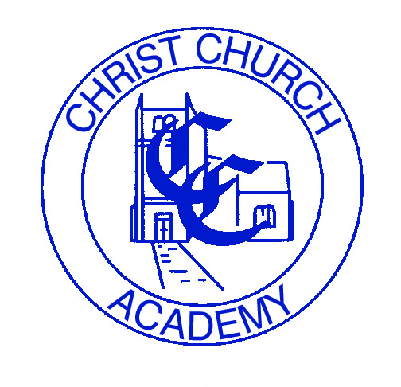
TEACHING ASSISTANT
PERSON SPECIFICATION

The following outlines the criteria for this post. Applicants who have a disability and who meet the criteria will be shortlisted.

Applicants should describe in their application how they meet these criteria.
 | CRITERIA
QUALIFICATIONS | Level 3 teaching assistant qualification or working towards
EXPERIENCE | Previous experience of working with children in an educational environment
SKILLS AND ABILITIES | - Numeracy & literacy skills  - Basic ICT skills  - Have the ability to relate well to children and adults, understanding their needs and being able to respond accordingly and with dignity and respect  - Good influencing skills to encourage pupils to interact with others and be socially responsible  - Have a good level of spoken and written English  - Be able to work as part of a team with flexibility and positivity  - Demonstrate a high level of professionalism  - Subscribe to our academy values
KNOWLEDGE | Knowledge of policies and procedures relating to child protection, health & safety, security, equal opportunities and confidentiality

